Bird Name
Font: Cambria, 60 point, Bold, Centered

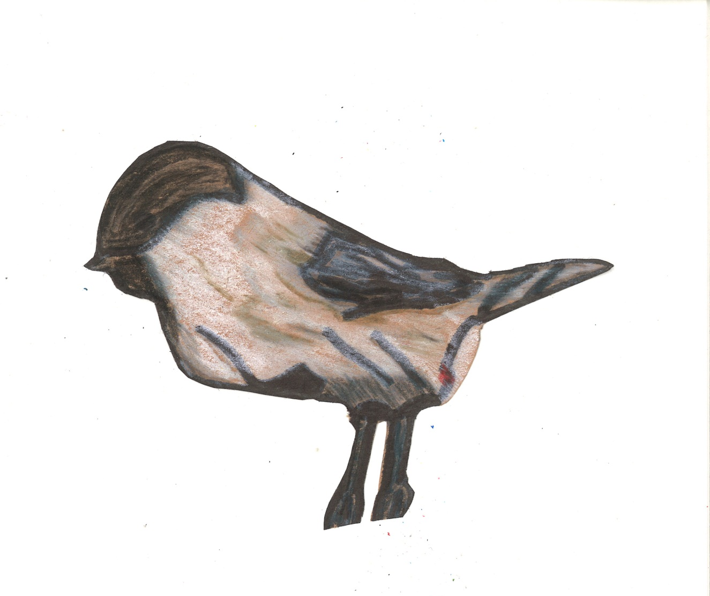
Insert bird picture
Rotate, resize, and crop as needed

Common Name:
Font: Cambria, 20 point

Font: Cambria, 24 point, Bold

Type name here
Scientific Name:
Type name here
Location:
Type location here
Habitat:
Type habitat here
Interesting Facts:
- Fact 1
- Fact 2
Font: Cambria, 16 point, Bold

Font: Cambria, 16 point

Researcher: Your Name

